**Experiment vi: ALU**

**Objective:**

1. To implement ALU using VHDL

**Theory:**

The Arithmetic and Logical unite is the fundamental component in a computing system like a computer. It is basically the actual data processing element within the central processing unit (CPU) in a computing system. It performs all the arithmetic and logical operations and forms the backbone of modern computer technology.

**Architecture:**

**--**design for alu

library IEEE;

use IEEE.STD_LOGIC_1164.ALL;

use IEEE.STD_LOGIC_UNSIGNED.ALL;

use ieee.NUMERIC_STD.all;

entity ALU is

generic ( constant N: natural:=1); -- number of shifted or rotated bits

Port (

A, B: in STD_LOGIC_VECTOR (7 downto 0); -- 2 inputs 8-bit

ALU_Sel: in STD_LOGIC_VECTOR (3 downto 0); -- 1 input 4-bit for selecting function

ALU_Out: out STD_LOGIC_VECTOR (7 downto 0); -- 1 output 8-bit

Carryout: out std_logic; -- Carryout flag

);

end ALU;

architecture Behavioral of ALU is

signal ALU_Result: std_logic_vector (7 downto 0);

signal tmp: std_logic_vector (8 downto 0);

begin

process(A,B,ALU_Sel)

begin

case(ALU_Sel) is

when "0000" => -- Addition

ALU_Result <= A + B ;

when "0001" => -- Subtraction

ALU_Result <= A - B ;

when "0010" => -- Multiplication

ALU_Result<=std_logic_vector(to_unsigned((to_integer(unsigned(A)) *

to_integer(unsigned(B))),8)) ;

when "0011" => -- Division

ALU_Result <= std_logic_vector(to_unsigned(to_integer(unsigned(A)) /

to_integer(unsigned(B)),8)) ;

when "0100" => -- Logical shift left

ALU_Result <= std_logic_vector(unsigned(A) sll N);

when "0101" => -- Logical shift right

ALU_Result <= std_logic_vector(unsigned(A) srl N);

when "0110" => -- Rotate left

ALU_Result <= std_logic_vector(unsigned(A) rol N);

when "0111" => -- Rotate right

ALU_Result <= std_logic_vector(unsigned(A) ror N);

when "1000" => -- Logical and

ALU_Result <= A and B;

when "1001" => -- Logical or

ALU_Result <= A or B;

when "1010" => -- Logical xor

ALU_Result <= A xor B;

when "1011" => -- Logical nor

ALU_Result <= A nor B;

when "1100" => -- Logical nand

ALU_Result <= A nand B;

when "1101" => -- Logical xnor

ALU_Result <= A xnor B;

when "1110" => -- Greater comparison

if(A>B) then

ALU_Result <= x"01" ;

else

ALU_Result <= x"00" ;

end if;when "1111" => -- Equal comparison

if(A=B) then

ALU_Result <= x"01" ;

else

ALU_Result <= x"00" ;

end if;

when others => ALU_Result <= A + B ;

end case;

end process;

ALU_Out <= ALU_Result; -- ALU out

tmp <= ('0' & A) + ('0' & B);

Carryout <= tmp(8); -- Carryout flag

end Behavioral;

**Source code:**

-- Testbench for alu adder

library IEEE;

use IEEE.std_logic_1164.all;

entity testbench is

-- empty

end testbench;

architecture tb of testbench is

-- DUT component

component ALU is

Port (

A, B: in STD_LOGIC_VECTOR (7 downto 0); -- 2 inputs 8-bit

ALU_Sel: in STD_LOGIC_VECTOR (3 downto 0); -- 1 input 4-bit for selecting function

ALU_Out: out STD_LOGIC_VECTOR (7 downto 0); -- 1 output 8-bit

Carryout: out std_logic; -- Carryout flag

);

end component;

signal A, B: std_logic_vector(7 downto 0);

signal ALU_Sel: std_logic_vector(3 downto 0);

signal ALU_out: std_logic_vector(7 downto 0);

signal Carryout: std_logic;

begin

-- Connect DUT

DUT: ALU

port map (

A => A,

B => B,

ALU_Sel => ALU_Sel,

ALU_out => ALU_out,

Carryout => Carryout

);

-- Test process

process

begin

-- Test cases

A <= "00001111";

B <= "00001100";

ALU_Sel<= "0000";

wait for 10 ns; -- Expected output: S_out = "0000", Cout_out = '0'

A <= "00001011";

B <= "00000110";

ALU_Sel <= "0001";

wait for 10 ns; -- Expected output: S_out = "0010", Cout_out = '0'

A <= "00000100";

B <= "00000011";

ALU_Sel <= "0010";

wait for 10 ns;

A <= "00001000";

B <= "00000100";

ALU_Sel <= "0011";

wait for 10 ns;

-- End of simulation

wait for 20 ns;

assert false report "End of simulation" severity failure;

end process;

end tb;

**Output:**

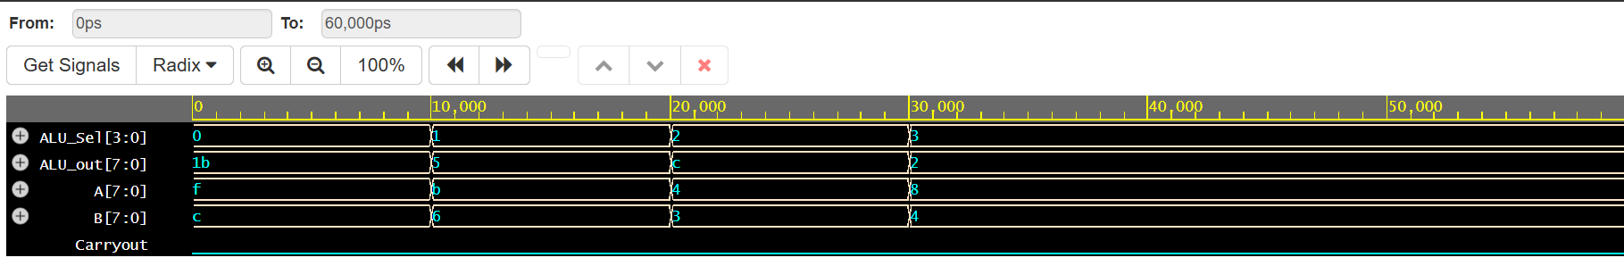

**Conclusion:**

In conclusion, designing an ALU in VHDL enables efficient implementation of arithmetic and logic operations in digital systems. VHDL's flexibility and modularity allow for easy testing, simulation, and refinement, ensuring reliable performance. It is a powerful tool for creating high-performance, cost-effective hardware designs.

**Experiment vii: 3-Segment Pipeline**

**Objective:**

1. To implement 3-Segment Pipeline using VHDL

**Theory:**

The Arithmetic and Logical unite is the fundamental component in a computing system like a computer. It is basically the actual data processing element within the central processing unit (CPU) in a computing system. It performs all the arithmetic and logical operations and forms the backbone of modern computer technology.

**Architecture:**

--design for pipeline

library IEEE;

use IEEE.STD_LOGIC_1164.ALL;

use IEEE.NUMERIC_STD.ALL;

entity pipeline is

Port (

a : in integer;

b : in integer;

c : in integer;

clk : in STD_LOGIC;

y : out integer

);

end pipeline;

architecture Behavioral of pipeline is

signal r1, r2, r3, r4, r5 : integer := 0;

begin

y <= r5;

process(clk)

begin

if rising_edge(clk) then

-- Pipeline stage 1

r1 <= a;

r2 <= b;

-- Pipeline stage 2 (registered)

r4 <= r1 + r2;

r3 <= c;

-- Pipeline stage 3 (registered)

r5 <= r4 * r3;

end if;

end process;

end Behavioral;

**Source code:**

--testbench for pipeline

library IEEE;

use IEEE.STD_LOGIC_1164.ALL;

use IEEE.NUMERIC_STD.ALL;

entity pipeline_tb is

end pipeline_tb;

architecture Behavioral of pipeline_tb is

component pipeline

Port (

a : in integer;

b : in integer;

c : in integer;

clk : in STD_LOGIC;

y : out integer

);

end component;

signal a, b, c : integer := 0;

signal y : integer;

signal clk : STD_LOGIC := '0';

constant clk_period : time := 10 ns;

begin

uut: pipeline port map (

a => a,

b => b,

c => c,

clk => clk,

y => y

);

-- Clock generation

clk_process: process

begin

clk <= '0';

wait for clk_period/2;

clk <= '1';

wait for clk_period/2;

end process;

-- Stimulus process

stim_proc: process

begin

-- Test case 1

a <= 2;

b <= 3;

wait for 3 ns;

c <= 4;

wait for clk_period*2;

-- Test case 2

a <= 5;

b <= 6;

wait for 5 ns;

c <= 7;

wait for clk_period*2;

-- Test case 3

a <= 10;

b <= 20;

wait for 5 ns;

c <= 30;

wait for clk_period*2;

-- End simulation

wait;

end process;

end Behavioral;

**Output:**

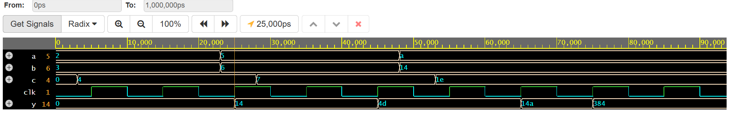

**Conclusion:**

In conclusion, implementing a 3-segment pipeline in VHDL enhances system performance by allowing parallel processing of data in stages. This approach increases throughput and reduces latency by efficiently organizing tasks across different pipeline segments. VHDL provides the necessary tools to model, simulate, and optimize the pipeline, ensuring smooth operation and scalability in complex digital systems.

**Experiment 4: Booth’s Multiplication Algorithm**

**Objective:**

1. To implement Booth’s Multiplication Algorithm.

**Theory:**

**Hardware Implementation**

It needs same hardware as that of addition and subtraction of signed-magnitude. In addition, it needs two more registers Q and SC.

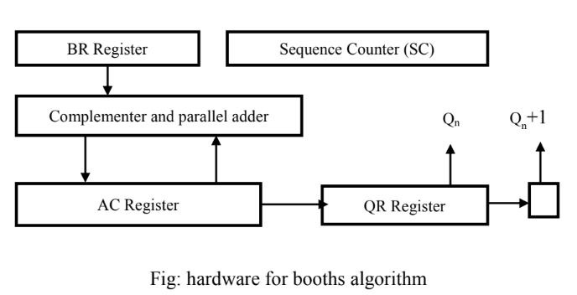

**Algorithm:**

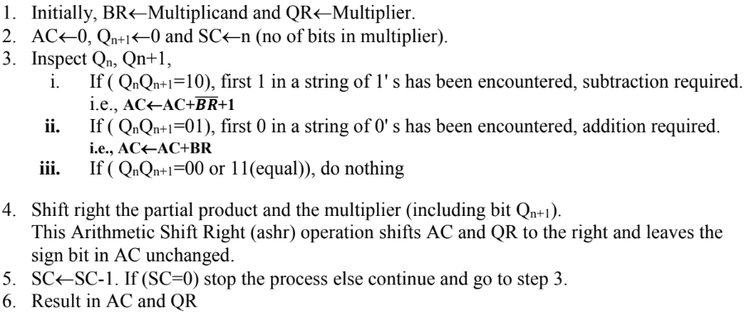

**Flowchart:**

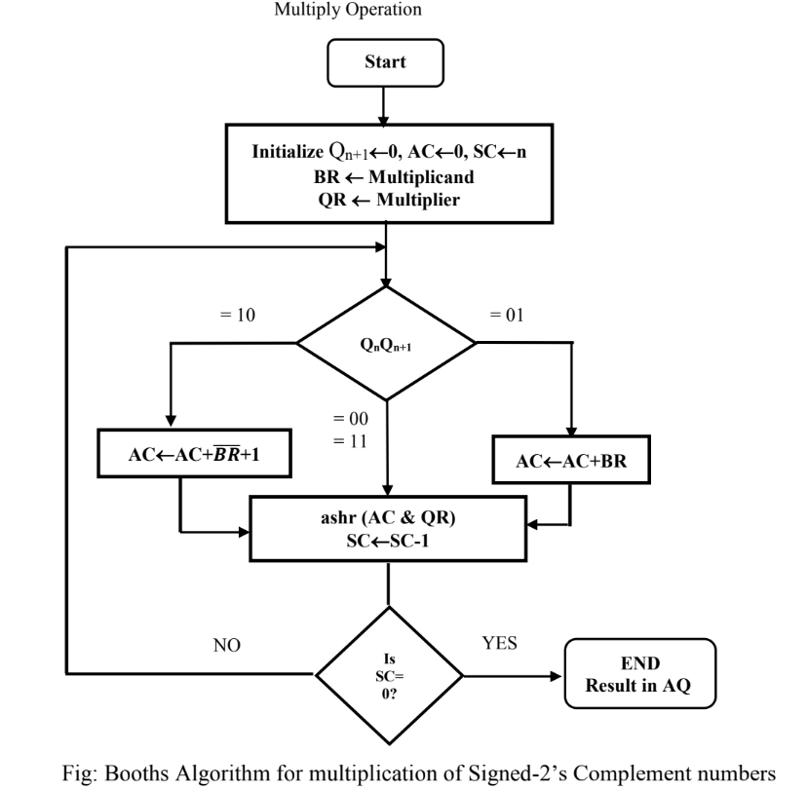

**Source code**

#include<iostream>

using namespace std;

void add(int a[], int x[], int q);

void complement(int a[], int n) {

int i;

int x[8] = { NULL };

x[0] = 1;

for (i = 0; i < n; i++) {

a[i] = (a[i] + 1) % 2;

}

add(a, x, n);

}

void add(int ac[], int x[], int q) {

int i, c = 0;

for (i = 0; i < q; i++) {

ac[i] = ac[i] + x[i] + c;

if (ac[i] > 1) {

ac[i] = ac[i] % 2;

c = 1;

}else

c = 0;

}

}

void ashr(int ac[], int qr[], int &qn, int q) {

int temp, i;

temp = ac[0];

qn = qr[0];

cout << "\t\tashr\t\t";

for (i = 0; i < q - 1; i++) {

ac[i] = ac[i + 1];

qr[i] = qr[i + 1];

}

qr[q - 1] = temp;

}

void display(int ac[], int qr[], int qrn) {

int i;

for (i = qrn - 1; i >= 0; i--)

cout << ac[i];

cout << " ";

for (i = qrn - 1; i >= 0; i--)

cout << qr[i];

}

int main(int argc, char **argv) {

int mt[10], br[10], qr[10], sc, ac[10] = { 0 };

int brn, qrn, i, qn, temp;

cout<<"**Booth Algorithm Compiled by Sarfraj Alam**\n"<<endl;

cout << "\n Number of multiplicand bit=";

cin >> brn;

cout << "\nmultiplicand=";

for (i = brn - 1; i >= 0; i--)

cin >> br[i]; //multiplicand

for (i = brn - 1; i >= 0; i--)

mt[i] = br[i];

complement(mt, brn);

cout << "\nNo. of multiplier bit=";

cin >> qrn;

sc = qrn;

cout << "Multiplier=";

for (i = qrn - 1; i >= 0; i--)

cin >> qr[i];

qn = 0;

temp = 0;

cout << "qn\tq[n+1]\t\tBR\t\tAC\tQR\t\tsc\n";

cout << "\t\t\tinitial\t\t";

display(ac, qr, qrn);

cout << "\t\t" << sc << "\n";

while (sc != 0) {

cout << qr[0] << "\t" << qn;

if ((qn + qr[0]) == 1) {

if (temp == 0) {

add(ac, mt, qrn);

cout << "\t\tsubtracting BR\t";

for (i = qrn - 1; i >= 0; i--)

cout << ac[i];

temp = 1;

}

else if (temp == 1) {

add(ac, br, qrn);

cout << "\t\tadding BR\t";

for (i = qrn - 1; i >= 0; i--)

cout << ac[i];

temp = 0;

}

cout << "\n\t";

ashr(ac, qr, qn, qrn);

}

else if (qn - qr[0] == 0)

ashr(ac, qr, qn, qrn);

display(ac, qr, qrn);

cout << "\t";

sc--;

cout << "\t" << sc << "\n";

}

cout << "Result=";

display(ac, qr, qrn);}

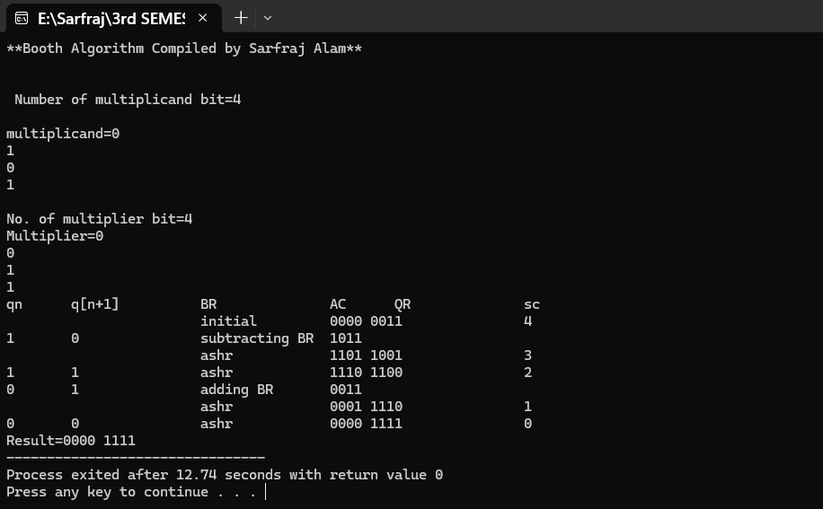**Output:**

**Conclusion:**

Booth’s Algorithm is an efficient way to multiply signed binary numbers using shifts and additions. It handles both positive and negative inputs with ease and mimics how real hardware performs multiplication

**Experiment 5: Restoring Division Algorithm**

**Objective:**

1. To implement Restoring Division Algorithm.

**Theory:**

**Hardware Implementation**

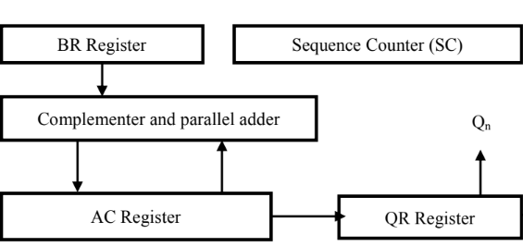

**Algorithm:**

**Step 1:** Initialize A, Q and M registers to zero, dividend and divisor respectively and counter to

n where n is the number of bits in the dividend.

**Step 2:** Shift A, Q left one binary position.

**Step 3:** Subtract M from A placing answer back in A. If sign of A is 1, set Q to zero and add M

back to A (restore A). If sign of A is 0, set Q to 1.

**Step 4:** Decrease counter; if counter > 0, repeat process from step 2 else stop the process. The

final remainder will be in A and quotient will be in Q.

**Flowchart:**

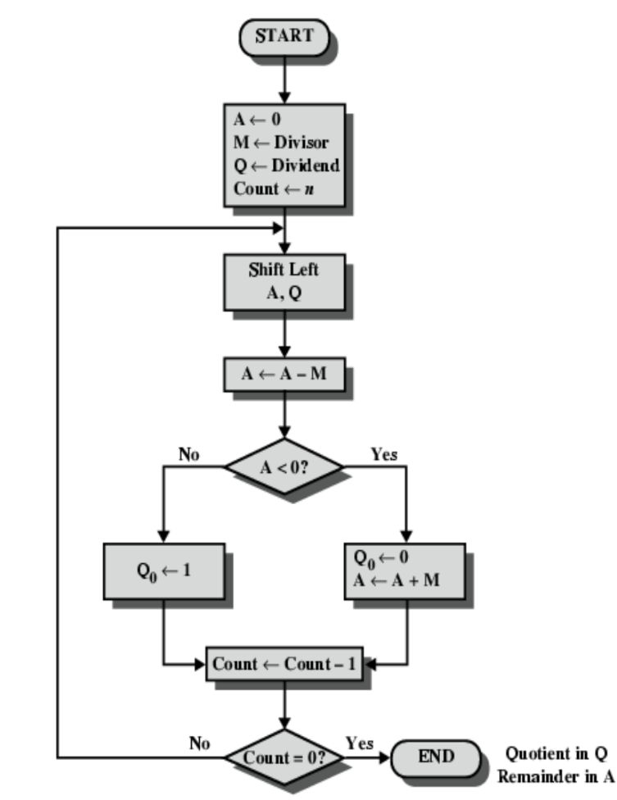

**Source code:**

#include <stdio.h>

void print_binary(int num, int bits) {

int i;

for (i = bits - 1; i >= 0; i--) {

printf("%d", (num >> i) & 1);

}

}

void print_step(int step, const char* op, int A, int Q, int bits) {

printf("| %2d | %-12s | ", step, op);

print_binary(A, bits);

printf(" | ");

print_binary(Q, bits);

printf(" |\n");

}

int main() {

int dividend, divisor;

int bits = 4;

int A, Q, M;

int step;

printf("**Restoring Algorithm By Sarfraj Alam**\n");

printf("Restoring Division Algorithm (4-bit)\n");

printf("Enter dividend (0-15): ");

scanf("%d", &dividend);

printf("Enter divisor (0-15): ");

scanf("%d", &divisor);

A = 0;

Q = dividend;

M = divisor;

step = bits;

printf("\n+----+--------------+--------+--------+\n");

printf("|Step| Operation | A | Q |\n");

printf("+----+--------------+--------+--------+\n");

print_step(step, "Initial", A, Q, bits);

for (step = bits; step > 0; step--) {

// Shift AQ left

A = (A << 1) | ((Q >> (bits-1)) & 1);

Q <<= 1;

print_step(step, "Shift AQ", A, Q, bits);

// Subtract M from A

A -= M;

print_step(step, "A = A - M", A, Q, bits);

if (A < 0) {

A += M; // Restore

print_step(step, "Restore A", A, Q, bits);

} else {

Q |= 1; // Set LSB

print_step(step, "Set Q0=1", A, Q, bits);

}

}

printf("+----+--------------+--------+--------+\n");

printf("\nResult: Quotient = %d, Remainder = %d\n", Q & 0xF, A & 0xF); // Mask to 4 bits

return 0;

}

**Output:**

**Conclusion:**

The Restoring Division Algorithm provides a systematic method to divide binary numbers using shifting and subtraction. It is simple to implement in C and effectively handles unsigned binary division, giving accurate quotient and remainder.